Assignment 4

Part II

Step 2:
Repository URI: 257810805238.dkr.ecr.us-west-2.amazonaws.com/hello-service

Step 3: Login Succeeded
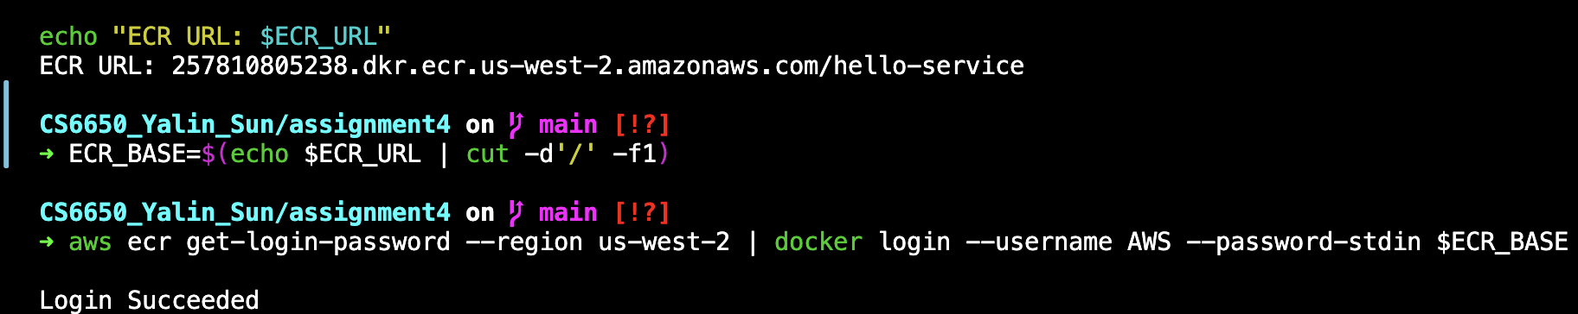

Build and push the image to ECR. The verified result:
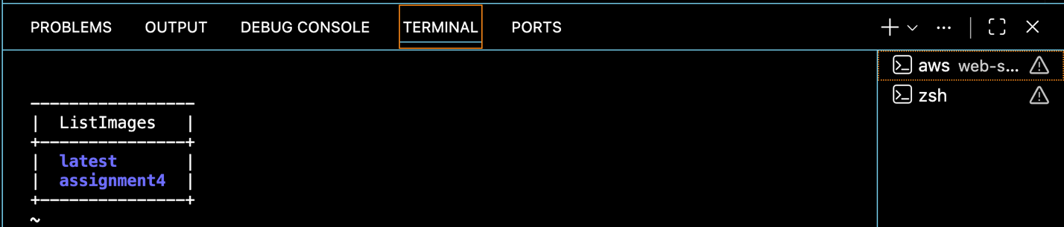

Step 4: Create ECS Cluster
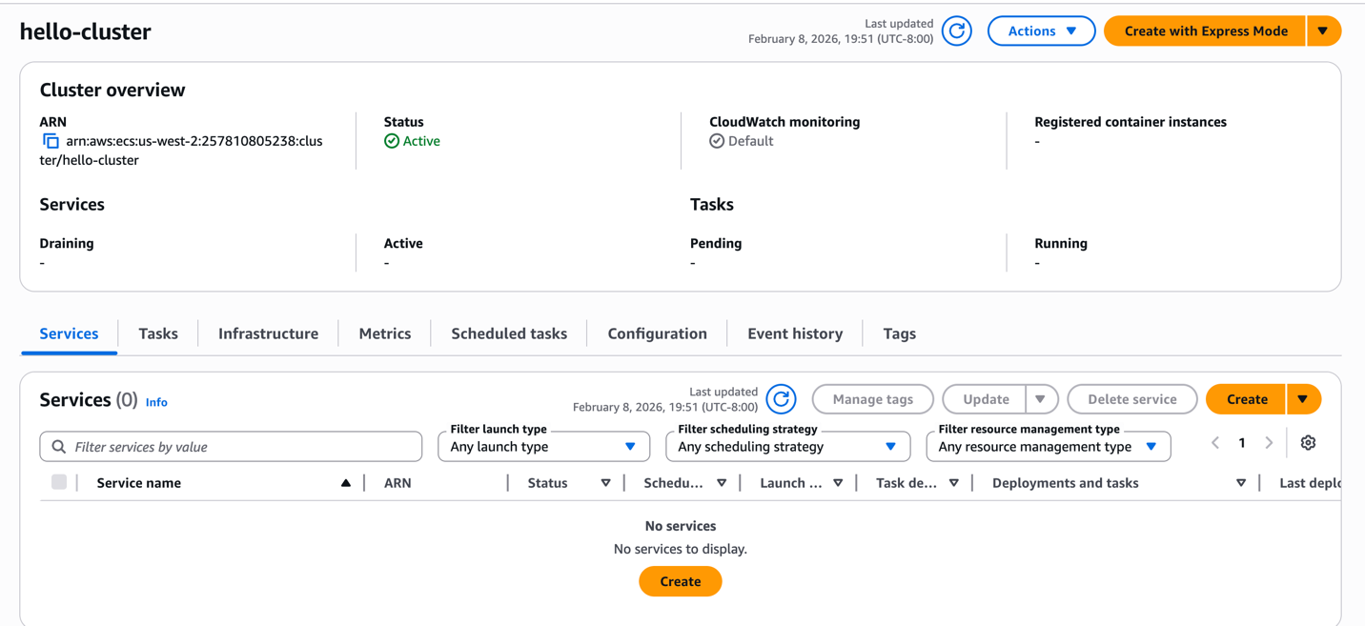

Step 5: Create Task Definition
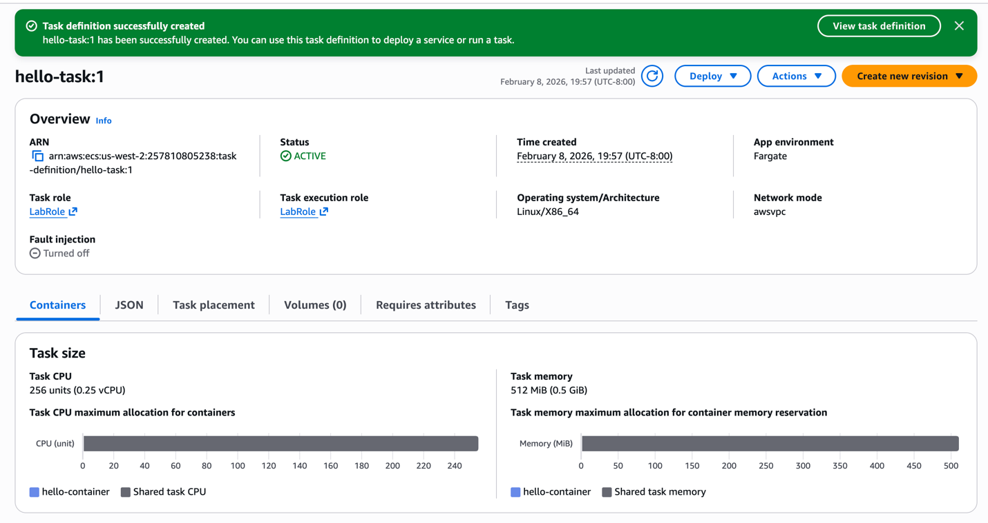

Step 6: Run a task
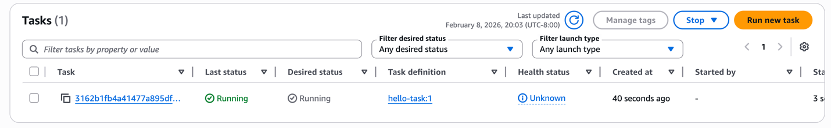

Step 7: Test the service.
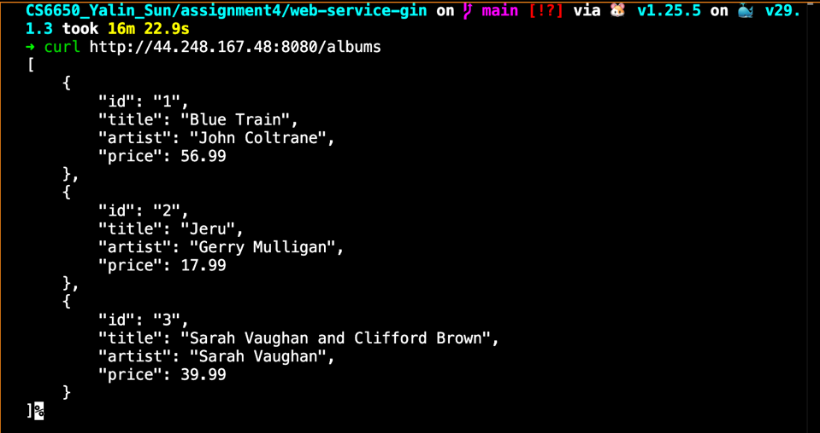

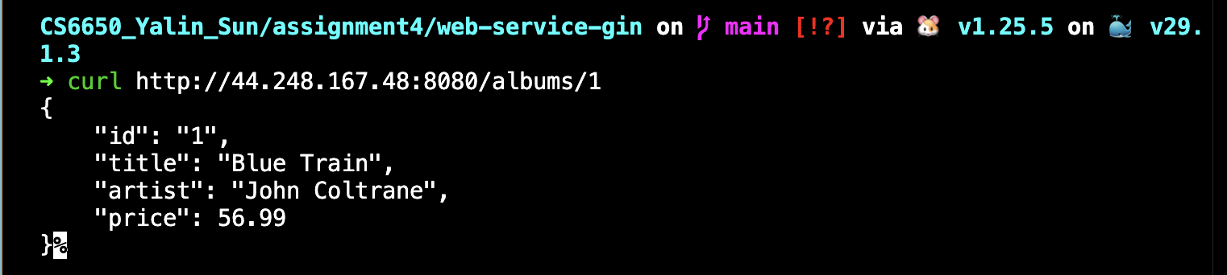
1. Difference in choosing EC2 vs ECS

EC2 is like renting a virtual machine where you manage almost everything yourself. You need to choose the instance type, install software, manage the operating system, and handle scaling and updates.

ECS is a container management service. Instead of managing servers, you focus on running containers. When using ECS with Fargate, AWS manages the servers for you, so you don’t need to worry about OS setup or instance maintenance.

In short:
EC2 → more control, more management
ECS (Fargate) → less management, easier deployment

2. What is a VPC and subnet? How did you get access to the default VPC?

A VPC (Virtual Private Cloud) is a private network in AWS where your resources run. It is like your own virtual data center in the cloud.

A subnet is a smaller network inside a VPC. It divides the VPC into sections, often mapped to different availability zones.

In this assignment, I used the default VPC, which AWS automatically creates for each account. The default VPC already includes subnets, routing, and internet access, so I did not need to configure networking manually. When running the ECS task, I simply selected the default VPC and one of its subnets.

3. What is TCP? How is it different than UDP?

TCP (Transmission Control Protocol) is a reliable communication protocol. It ensures that data is delivered in order and without loss. If packets are missing, TCP retransmits them.

UDP (User Datagram Protocol) is faster but does not guarantee delivery or order. It sends data without checking if it arrives correctly.

In short:
TCP → reliable, ordered, slower
UDP → fast, no delivery guarantee

In this assignment, TCP is used because HTTP traffic (such as REST APIs) requires reliable data transfer.

4. How do you control resources allocated to a task?

In ECS with Fargate, resources are controlled in the Task Definition.

I specify:
CPU (for example, 0.25 vCPU)
Memory (for example, 0.5 GB)

These settings limit how much CPU and memory the container can use. This makes sure each task has enough resources and prevents it from using more than expected.

Part III

Step 1: Create S3 Bucket
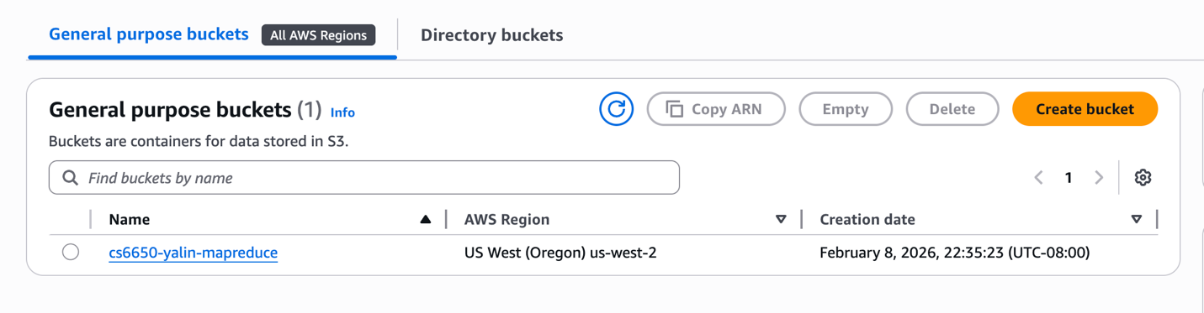
Step 2A: Create Splitter
